**PROCEDURE AND RESULTS**

READ THE DATA:

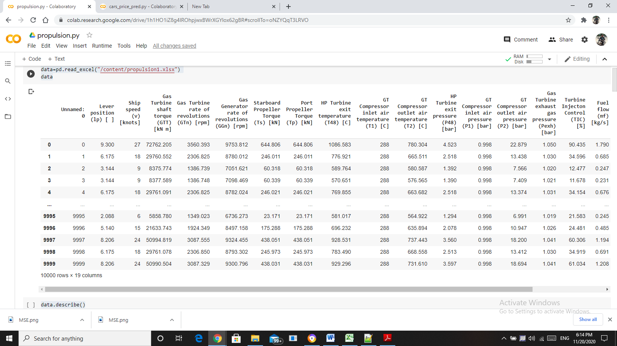

DATA DESCRIPTION:

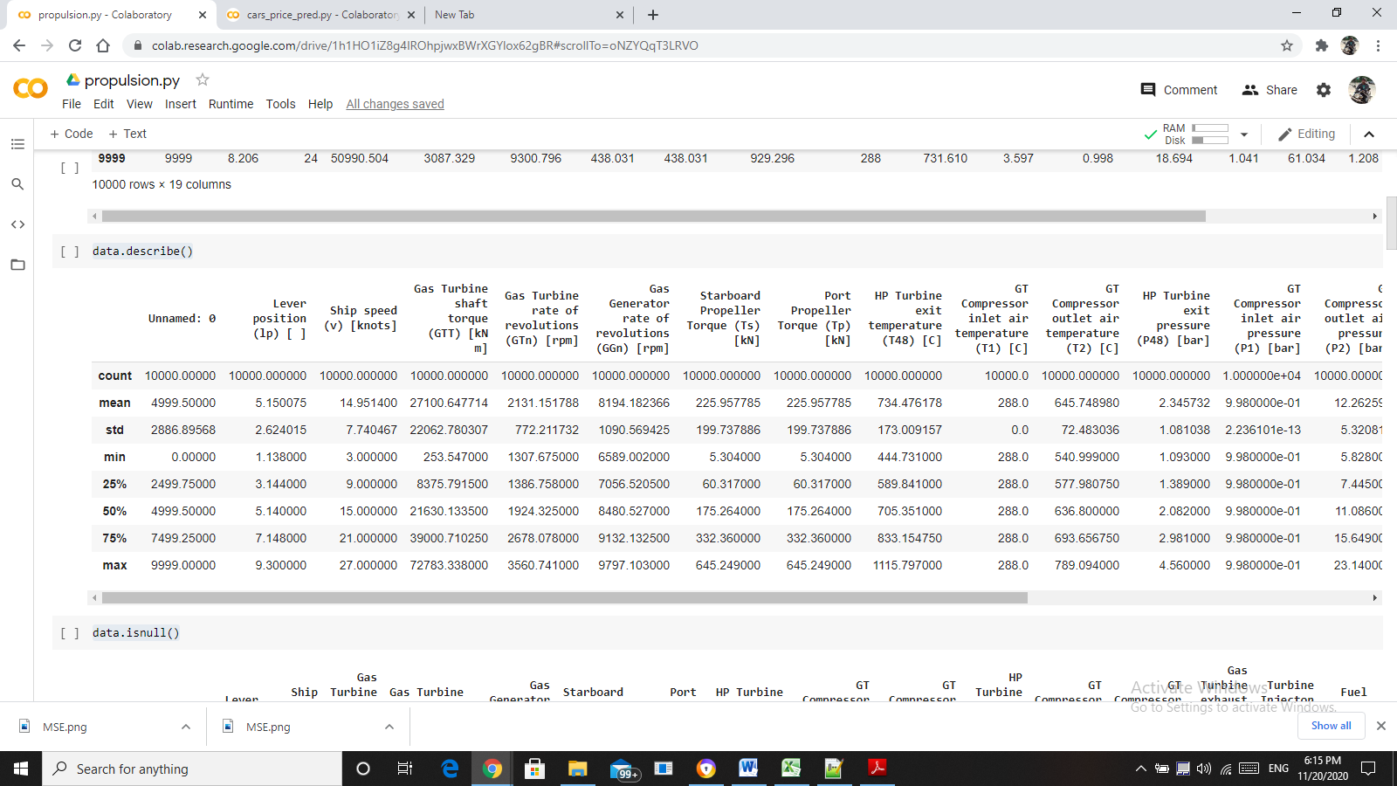

CHECKING FOR NULL VALUES:

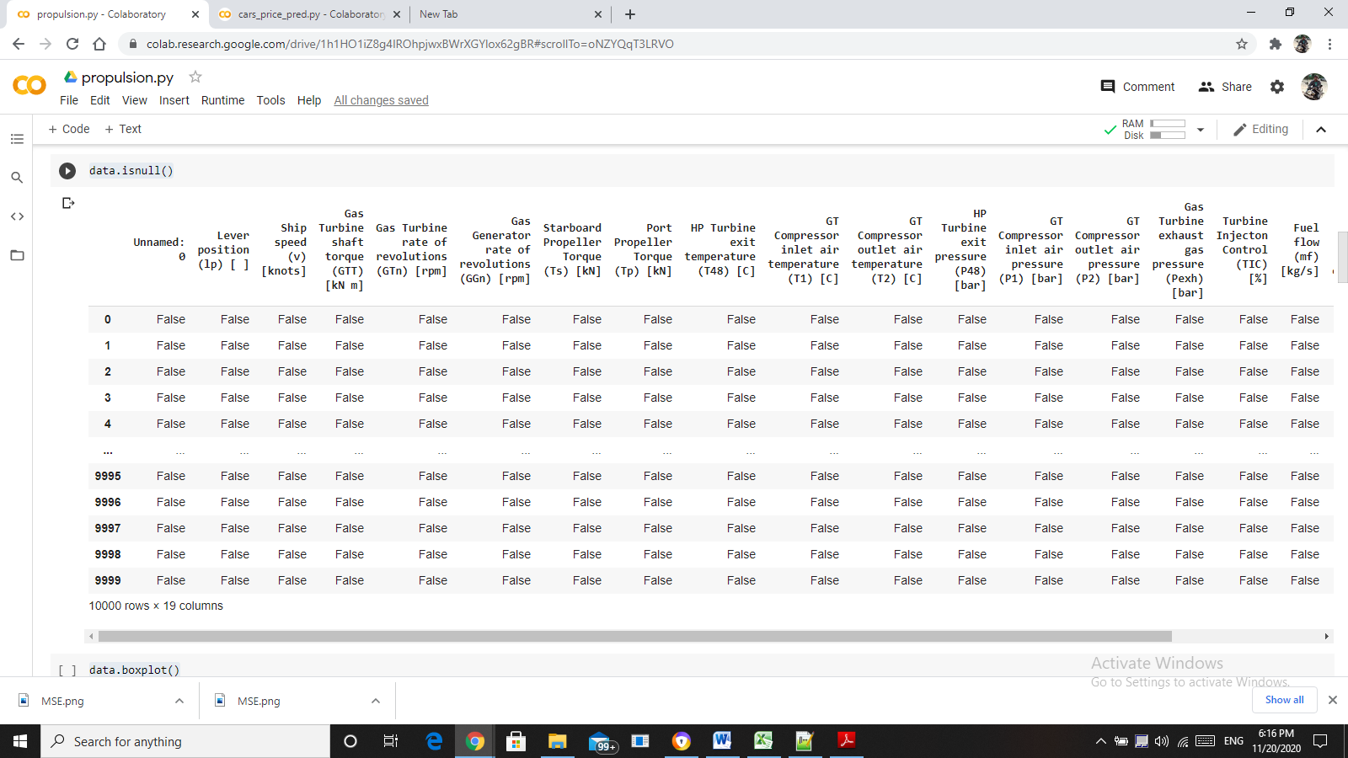

DETECTION OF OUTLIERS:

Using boxplot the outliers can be detected.

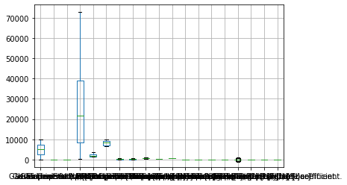

SPLITING THE DATA INTO TRANING AND TESTING SETS

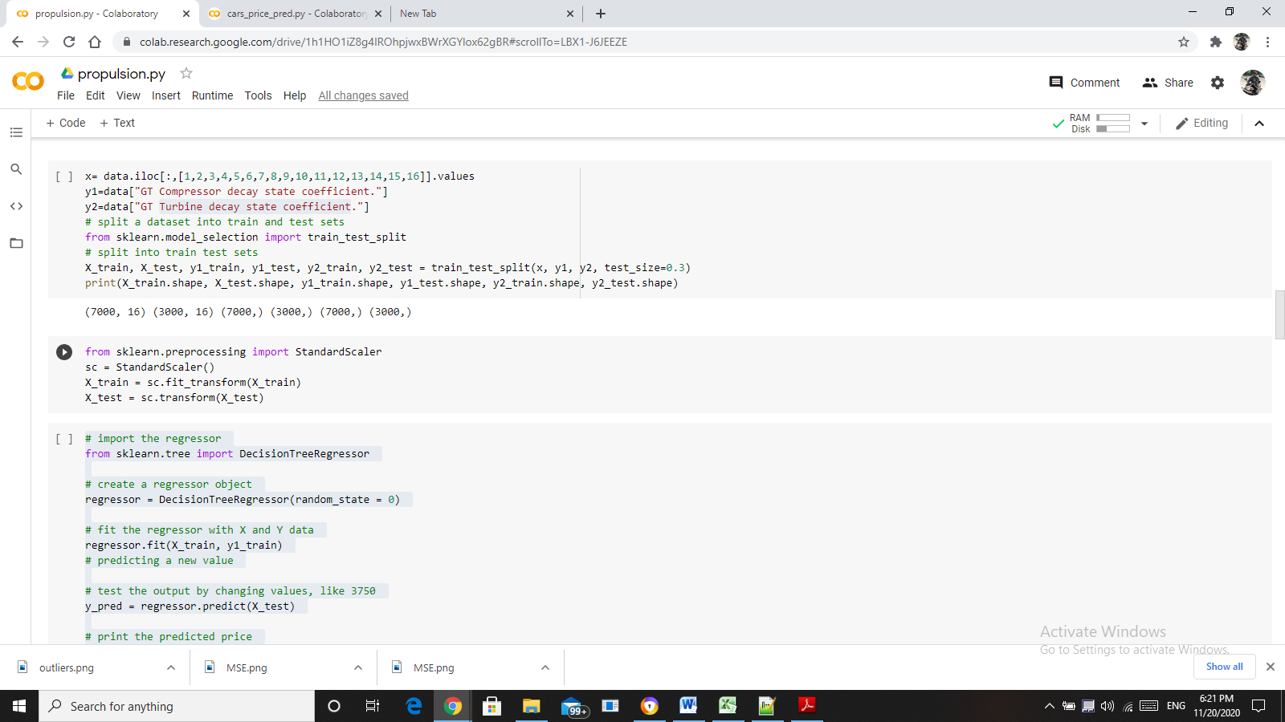

The data is divided into 70% for training and 30 for testing.

**RESULTS FOR GT COMPRESSOR DECAY STATE CO-EFFICIENT**

MODEL NAME: LINEAR REGRESSION

R-square value: 1.0

Mean Square Error: 3.3345758721206264e-05

MODEL NAME: DECISION TREE REGRESSOR

R-square value: 1.0

Mean Square Error: 3.6479382716048593e-06

MODEL NAME: RANDOM FOREST REGRESSOR

R-square value: 1.0

Mean Square Error: 0.00018886040377190624

MODEL NAME: LINEAR SUPPORT VECTOR REGRESSOR

R-square value: 1.0

Mean Square Error: 0.0002193260000000005

MODEL NAME: rbf SUPPORT VECTOR REGRESSOR

R-square value: 1.0

Mean Square Error: 0.00021932600000000073

**PLOT FOR MEAN SQUARE ERROR:**

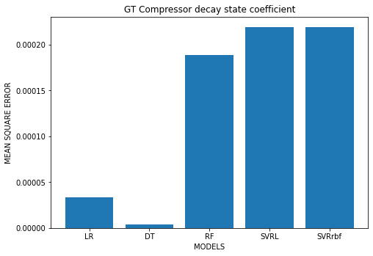

**INFERENCE:**

As per the above graph, while comparing the mean square errors of the models, the mean square error of the DECISION TREE REGRESSOR is low. Hence, the Decision tree regression model is the best fit.

**RESULTS FOR GT TURBINE STATE CO-EFFICIENT**

MODEL NAME: LINEAR REGRESSION

R-square value: 1.0

Mean Square Error: 4.897460107556257e-06

MODEL NAME: DECISION TREE REGRESSOR

R-square value: 1.0

Mean Square Error: 1.5276837189440494e-06

MODEL NAME: RANDOM FOREST REGRESSOR

R-square value: 1.0

Mean Square Error: 5.037769809476938e-05

MODEL NAME: LINEAR SUPPORT VECTOR REGRESSOR

R-square value: 1.0

Mean Square Error: 5.634400000000012e-05

MODEL NAME: rbf SUPPORT VECTOR REGRESSOR

R-square value: 1.0

Mean Square Error: 5.634400000000012e-05

**PLOT FOR MEAN SQUARE ERROR:**

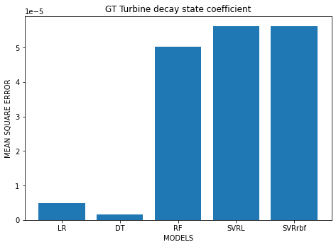

**INFERENCE:**

As per the above graph, while comparing the mean square errors of the models, the mean square error of the DECISION TREE REGRESSOR is low. Hence, the Decision tree regression model is the best fit.